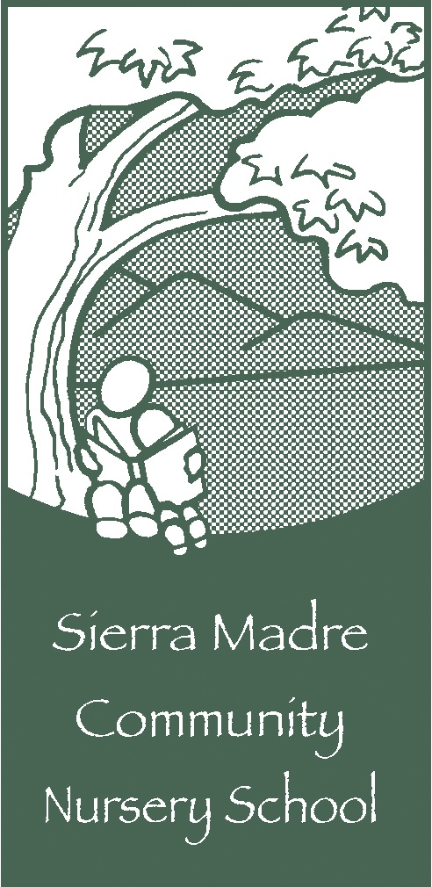

September 22, 2017

Dear Friend of the Sierra Madre Community Nursery School:

We are writing to humbly ask for an in-kind donation to our non-profit nursery school in Sierra Madre.

The Sierra Madre Community Nursery School is a non-profit, parent participation preschool and kindergarten that has been nurturing young children in the San Gabriel Valley since 1947. Since its inception, parents and friends of the school have provided the manpower to build and maintain its facilities. Over the years, SMCNS has become one of the largest, most respected parent co-operative preschools in California.

We have traditionally kept our tuition low, so that children from all backgrounds have the opportunity to attend. As a result, we rely heavily on fundraising and the generosity of the business community. Our 28th Annual Live and Silent Auction, to be held November 4, 2017, is our largest fundraising event of the year. Our 2017 goal is to raise $30,000. This money will provide our school with the funds necessary to continue our longstanding tradition of creative, experimental education, incorporating science, music, and the arts.

We invite you to support our school by making a tax-deductible donation to be included in our Auction. This is an excellent opportunity to expose your business to over 150 young families who are putting down roots in our community. Each donor will be acknowledged in the Auction catalog alongside a description of their donation. Businesses that donate an item or service valued at $100 or more will be recognized as Business Sponsors. We will need your donation by October 16, 2017 in order to give you credit in our catalog. It is helpful also to include a business card or leaflet so we can present your contribution in the most attractive manner possible and maximize your visibility to the attendees.

Thank you for your consideration of our request. Please do not hesitate to call SMCNS at 626-355-1655 if you would like more information about our school. Additionally, we are happy to arrange a pick-up of your donation item. Please email me at chaneybrewer@aol.com. Otherwise, you can mail or drop your donation at the school.

Thank you for your support.

Best wishes,

Anne Chaney
Business Procurement Chair, SMCNS 2017 Auction

Tax ID #95-1684090

701 East Sierra Madre Blvd Sierra Madre CA 91024

